Computer Programming  
Lab Tasks



Department of Computer Science - BUIC

Name: Saad Ahmad

Enrollment Number: 01-134222-130

**Exercises/Lab Journal 5**

**Task 1:** Writea C++ program using for loop, that takes a number from the user, check if number is even then displays its table till 10 multiples. Output should be in the form à 2 x 1 = 2

**Code:**

#include <iostream>

using namespace std;

int main() {

int num;

int i;

int j;

int a;

for (j = 1; j >= 1; ) {

cout << "Enter 0 to terminate the program" << endl;

cout << "Enter a number : " << endl;

cin >> num;

if (num == 0) {

break;

}

if (num % 2 == 0) {

for (i = 1; i <= 10; i++) {

cout << num << " x " << i << " = " << num * i << endl;

}

}

else {

cout << "Number is not even" << endl;

}

cout << "Press 1 to run the program again" << endl;

cin >> a;

if (a == 1) {

j++;

}

else {

break;

}

system("CLS");

}

return 0;

}

**Output:**

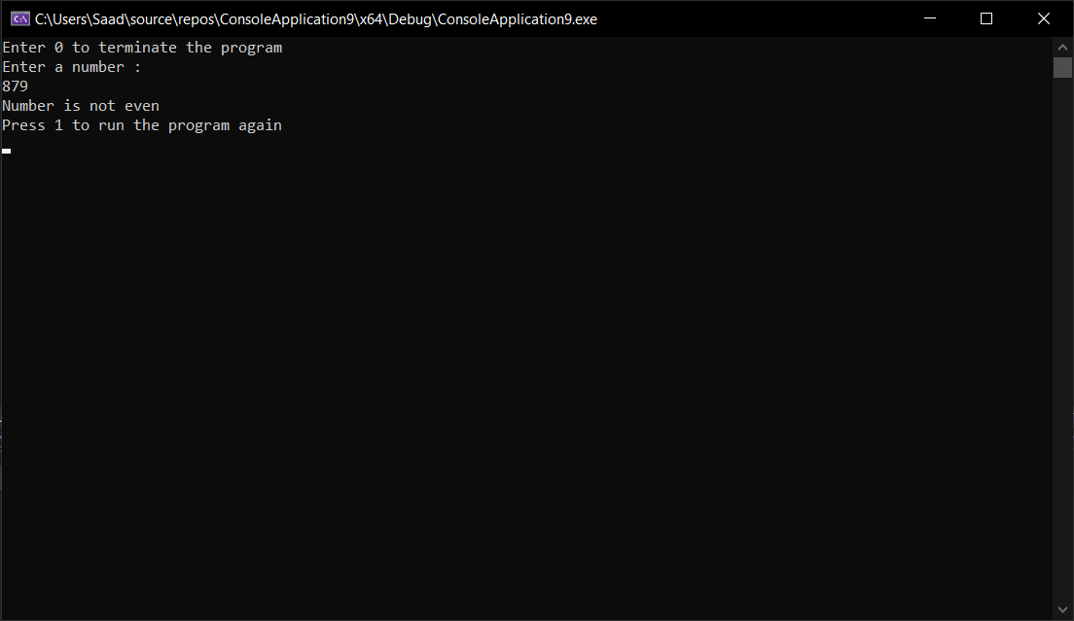

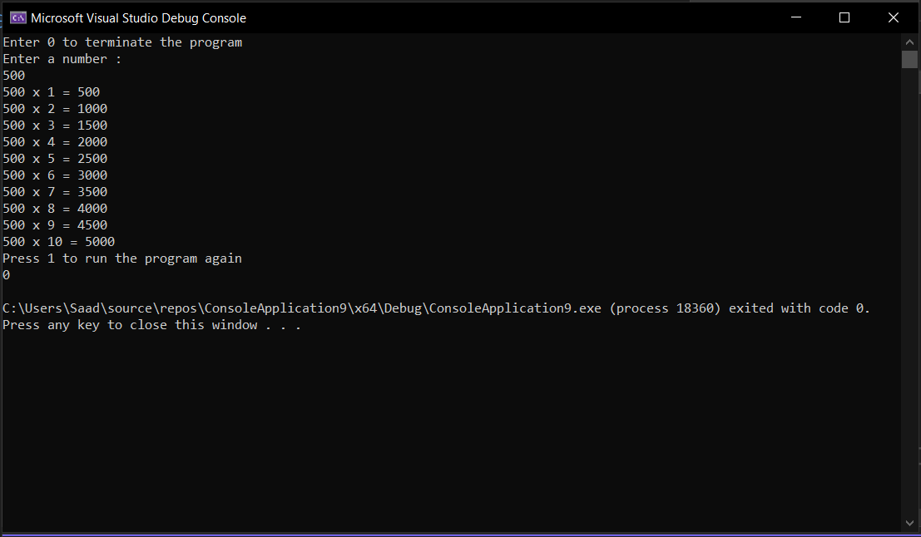

**Task 2:**

Write a program using for loop to extract even number from the range of integers given from the keyboard and then print them on the screen. Your program output should be like:

Input starting integer: 6

Input ending integer: 12

Even numbers are: 6 8 10 12

**Code :**

#include <iostream>

using namespace std;

int main() {

int num1;

int num2;

int i;

cout << "Input starting integer :";

cin >> num1;

cout << "Input ending integer:";

cin >> num2;

cout << "Even numbers are";

for (i = 0; num1 <= num2; num1++) {

if (num1 % 2 == 0) {

cout << " " << num1;

}

}

return 0;

}

**Output:**

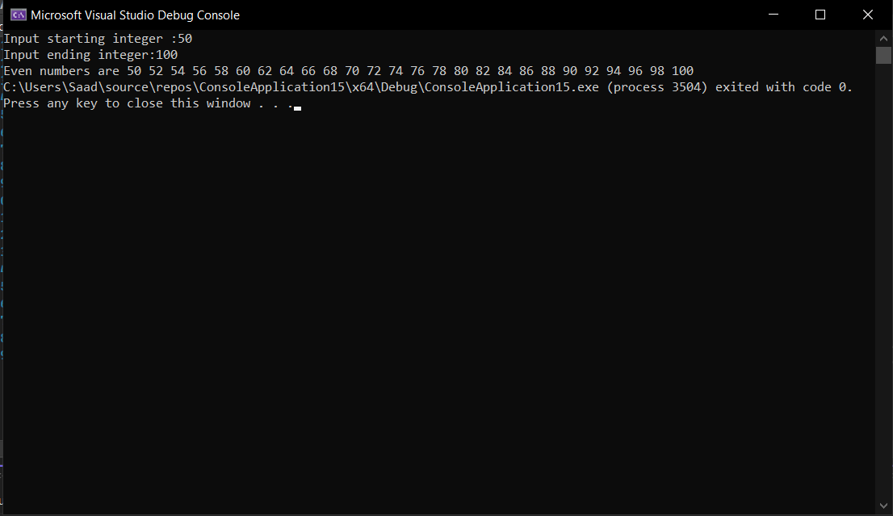

**Task 3:**

Write a C++ program using nested for loop to print the following pyramid.

A

B B

C C C

D D D D

E E E E E

**Code:**

#include <iostream>

using namespace std;

int main() {

char alphabet = 'A';

for (int i = 1; alphabet <= 'E';i--) {

for (int j = 1; j >= i; j--) {

cout << " " << alphabet;

}

alphabet++;

cout << endl;

}

return 0;

}

**Output:**

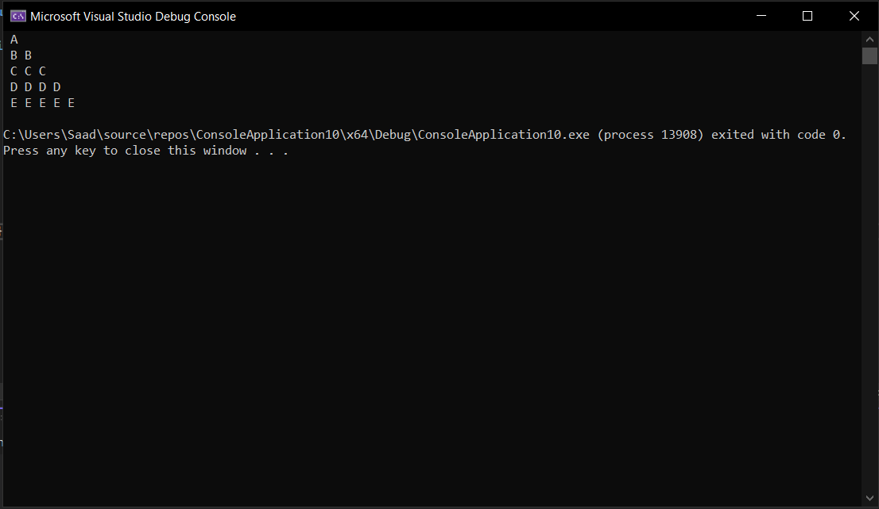

**Task 4:** Writea C++ program using nested for loop to print the following pyramid.

1 2 3 4 5

1 2 3 4

1 2 3

1 2

1

**Code:**

#include <iostream>

using namespace std;

int main() {

int i;

int j;

for (i = 5; i >= 1; i--) {

for (j = 1; j <= i; j++) {

cout << j << " ";

}

cout << endl;

}

return 0;

}

**Output:**

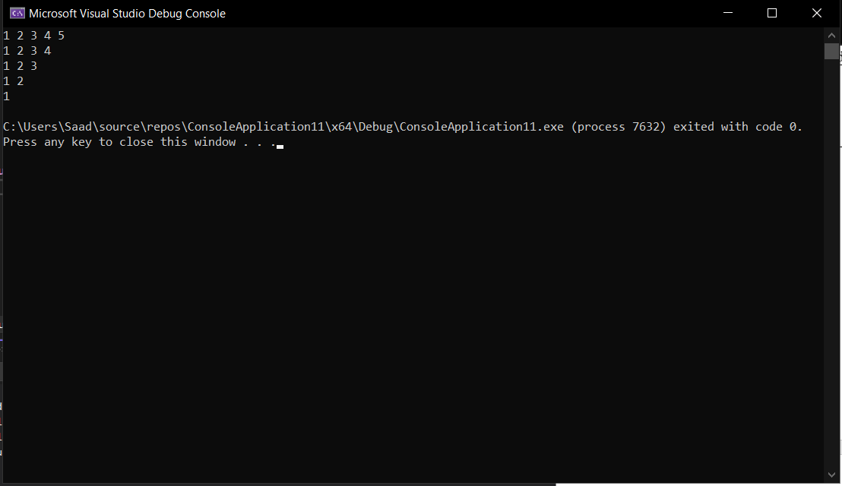

**Task 5:** Writea C++ program using nested for loop to print the following pyramid.

*

***

*****

*******

*********

*******

*****

***

*

**Code:**

#include <iostream>

using namespace std;

int main() {

int i;

int j = 1;

int space = 10;

for (i = 1; i <= 9; i++) {

if (i % 2 == 0) {

continue;

}

for (j = 2; j <= space; j++ ){

cout << " ";

}

space--;

for (j = 1; j <= i; j++) {

cout << "*";

}

cout << endl;

}

for (i = 8; i >= 1; i--) {

if (i % 2 == 0) {

continue;

}

for (j = 0; j <= space; j++) {

cout << " ";

}

space++;

for (j = 1; j <= i; j++) {

cout << "*";

}

cout << endl;

}

return 0;

}

**Output:**

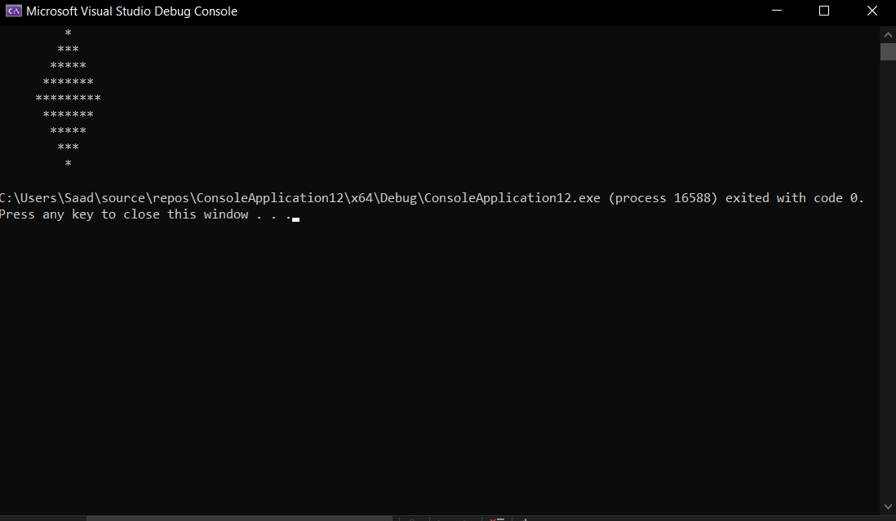

**Task 6:**

Write a program that takes integer number as input and print Alphabets in Upper Case letter and Lower Case Letter Using for Loop.

For Example: if the user enter 65 as integer number it will display Alphabets in Upper Case letter and if the user enter 97 as integer number it will display alphabets in Lower Case Letter.

Hint: Upper Case letter in ASCII start from 65 and end at 90.

Hint: Lower Case Letter in ASCII start from 97 and end at 122.

**Code:**

#include <iostream>

using namespace std;

int main() {

int num;

int i;

int j;

for (j = 1; j <= 1;) {

cout << "Enter a number between 65 to 90 or 97 and 122 : " << endl;

cin >> num;

if (num >= 65 && num <= 90) {

for (i = 65; i <= 90; i++) {

cout << (char)i << " ";

}

break;

}

else if (num >= 97 && num <= 122) {

for (i = 97; i <= 122; i++) {

cout << (char)i << " ";

}

break;

}

else {

cout << "Enter a valid number" << endl;

j--;

}

}

return 0;

}

**Output:**

